AIM: To design a 3:8 decoder

IC USED: 7404(NOT), 7408(AND).

THEORY: A **decoder** is a device which does the reverse of an [encoder](http://en.wikipedia.org/wiki/Encoder), undoing the encoding so that the original information can be retrieved. The same method used to encode is usually just reversed in order to decode.

In digital electronics, a decoder can take the form of a multiple-input, multiple-output [logic circuit](http://en.wikipedia.org/wiki/Logic_gate) that converts coded inputs into coded outputs, where the input and output codes are different.

Decoders have 3 inputs and 8 outputs. The binary input fed at input will be decoded to provide either logical high or low on one of the 8 outputs, which is termed as octal equivalent for that binary input. For a binary input 100, which is 4 in octal number system, the output pin called O4 will go either high or low.

.

SCHEMATIC:

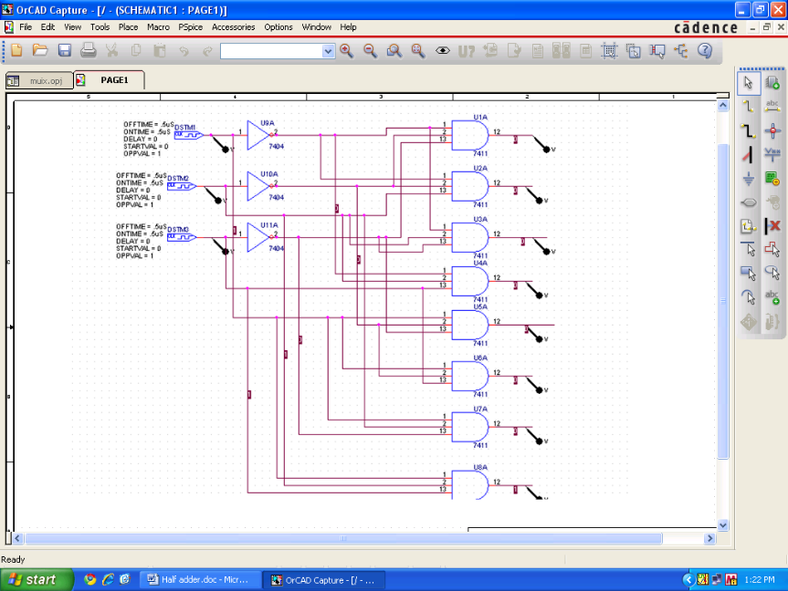

WAVEFORM:

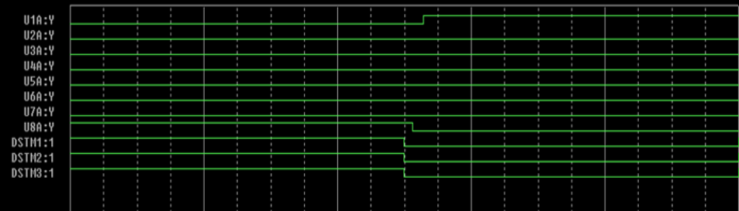

RESULT: 3:8 decoder is designed and its output is verified.